**Lesson Twenty-Two: The Last Week of the Life of Jesus - IV**

**Jesus Predicts, the Rulers Plot for, and Judas Bargains for Jesus’ Death (Matthew 26:1-5,14-16; Mark 14:1-2,10-11; Luke 22:1-6)**

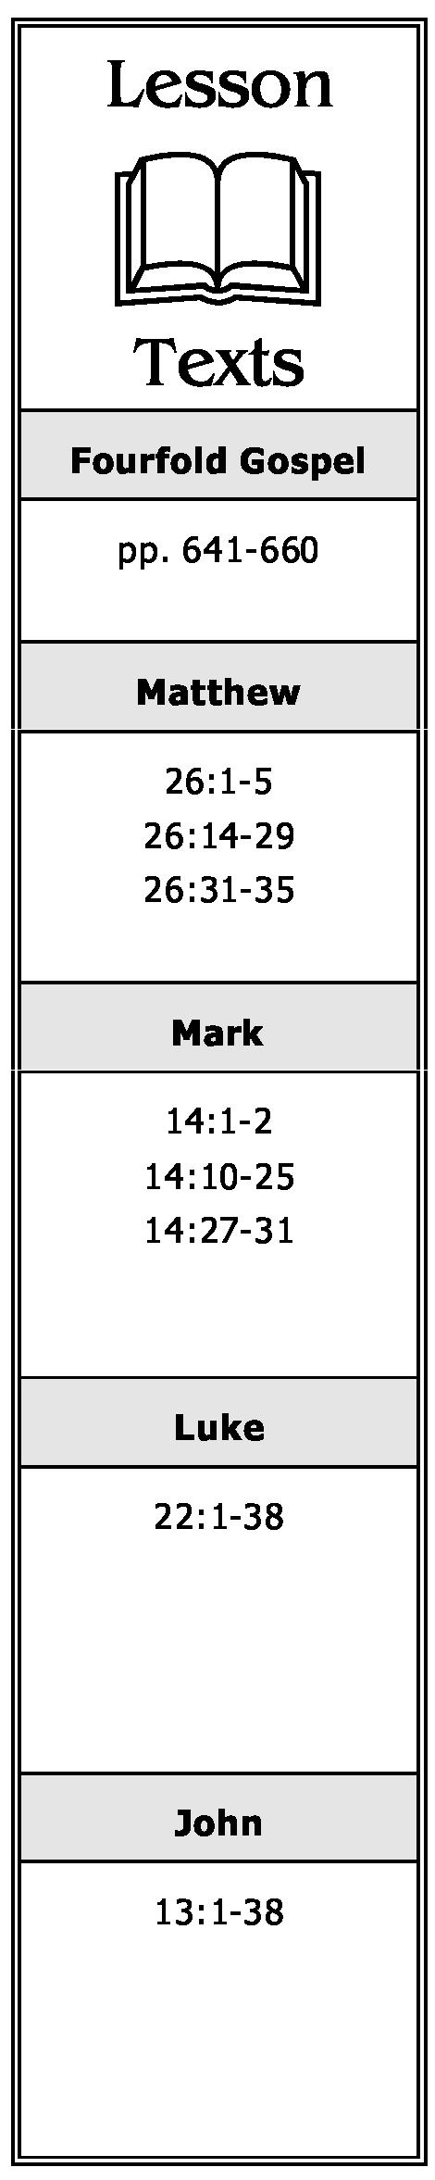

1. What was another name for the Passover? How many days were there until it occurred?

2. What prediction did Jesus make concerning the Passover?

3. Where had the chief priests and elders of the Jews assembled? Why had they assembled there?

4. What offer did Judas make to the chief priests and elders of the Jews? What was their reaction? Why did Judas do such a thing?

**Preparation for the Passover. Disciples Contend for Precedence (Matthew 26:17-20; Mark 14:12-17; Luke 22:7-18,24-30)**

5. Whom did Jesus send to prepare for the Passover? What were their instructions, i.e., how were they to know where to go, etc.?

6. Who observed the Passover with Jesus? What did He tell them as to when He would:

1. Eat of it again?
2. Drink the fruit of the vine again?

7. While in the upper room, what dispute arose among the disciples? How did Jesus answer this dispute?

**The Passover Meal. Jesus Washes the Disciples’ Feet (John 13:1-20)**

8. What did Jesus do immediately after supper?

**A Chronological Study of the Life of Jesus Gene Taylor** 58

1. Which apostle, at first, refused to allow Jesus to wash his feet? Why did he change his mind? Then what did he want Jesus to do? What response did Jesus give him?
2. What did Jesus say was His purpose in washing the disciples’ feet?
3. Why did Jesus say that not all of His disciples were “clean”?
4. How did Jesus identify the disciple who had “lifted up his heel against” Him?

**Judas’ Betrayal and Peter’s Denial Foretold**

**(Matthew 26:21-25,31-35; Mark 14:18-21, 27-31; Luke 22:21-23,31-38; John 13:21-38)**

1. When Jesus said one of the disciples would betray Him, what question did the disciples ask Him? How did He identify the betrayer?
2. After giving Judas the piece of bread He had dipped, what did Jesus say to him? What did the other disciples think when Judas left?
3. After Judas had departed, what did Jesus say to the remaining disciples?
4. What new commandment did Jesus give the disciples? Why would it be considered “new?” What would their obedience to this command illustrate to others?
5. What objection did Peter raise? What was Jesus’ response to him?
6. What preparations did Jesus tell the disciples they would now have to make? Why were such preparations necessary?

**The Lord’s Supper Instituted (Matthew 26:26-29; Mark 14:22-25; Luke 22:19-20;  
1 Corinthians 11:23-26)**

1. What new feast did Jesus institute while gathered with His disciples in the upper room?
2. What new significance did Jesus give the unleavened bread? The fruit of the vine?

**A Chronological Study of the Life of Jesus Gene Taylor** 59